**Review Chapter 2: Udagram**

1. **The project demonstrates an understanding of a good cloud git process:**

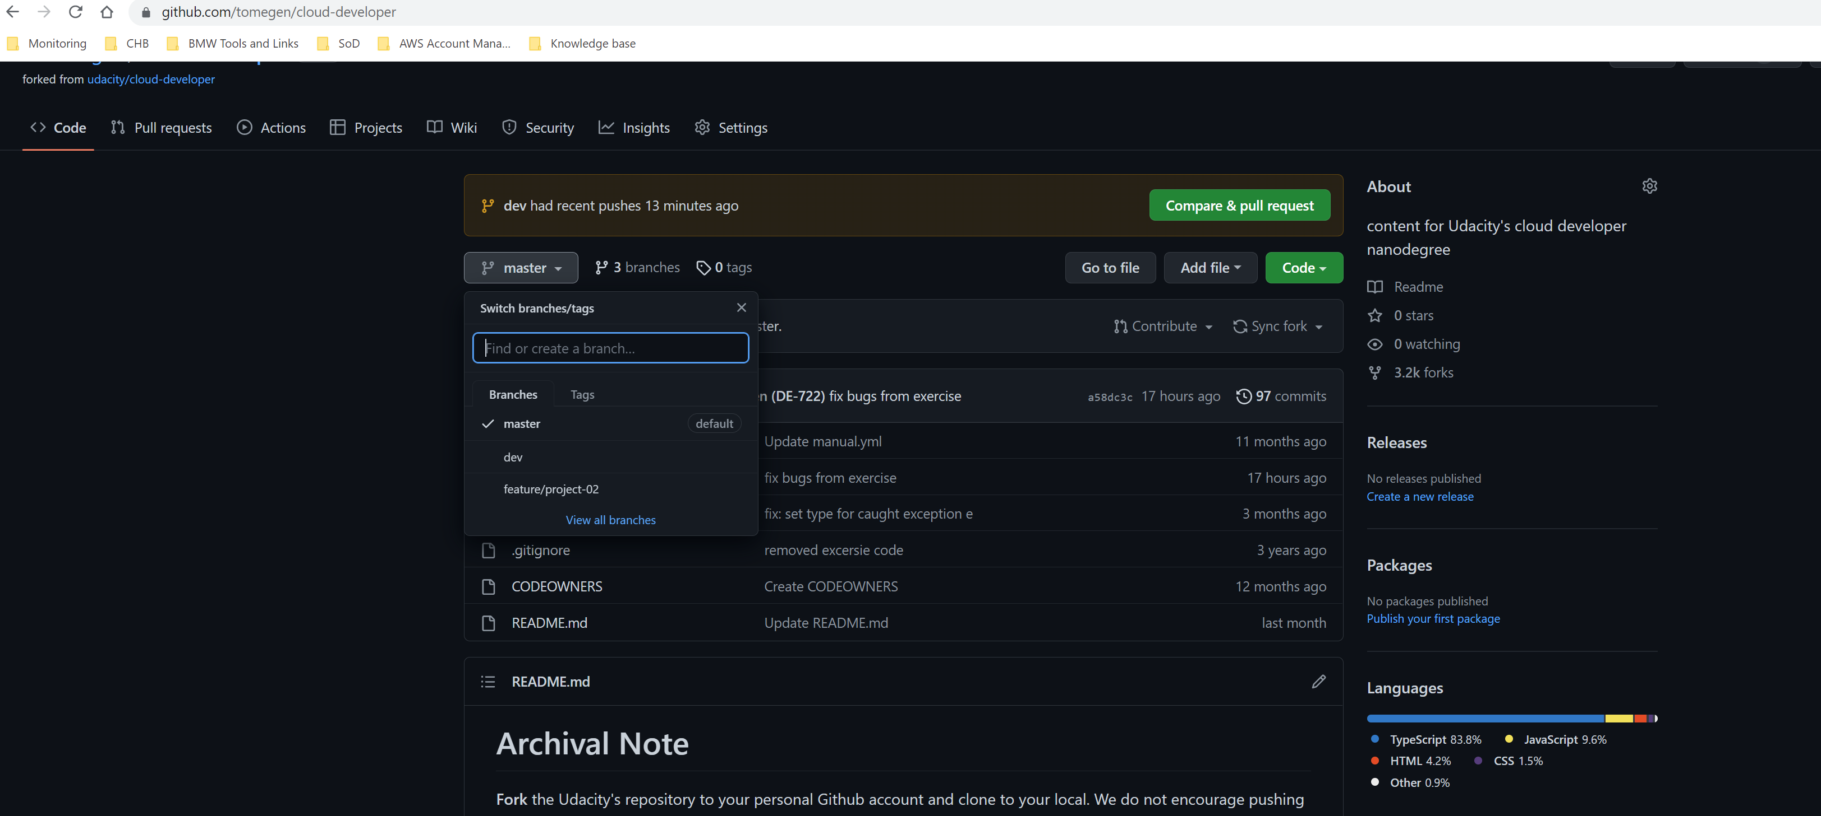

Three branches: master: Current stable code that can be used in production, dev: current stable code for development, feature/project-02: Current code for the new feature for this project.

1. **The project demonstrates an ability to use typescript and Nodejs:**

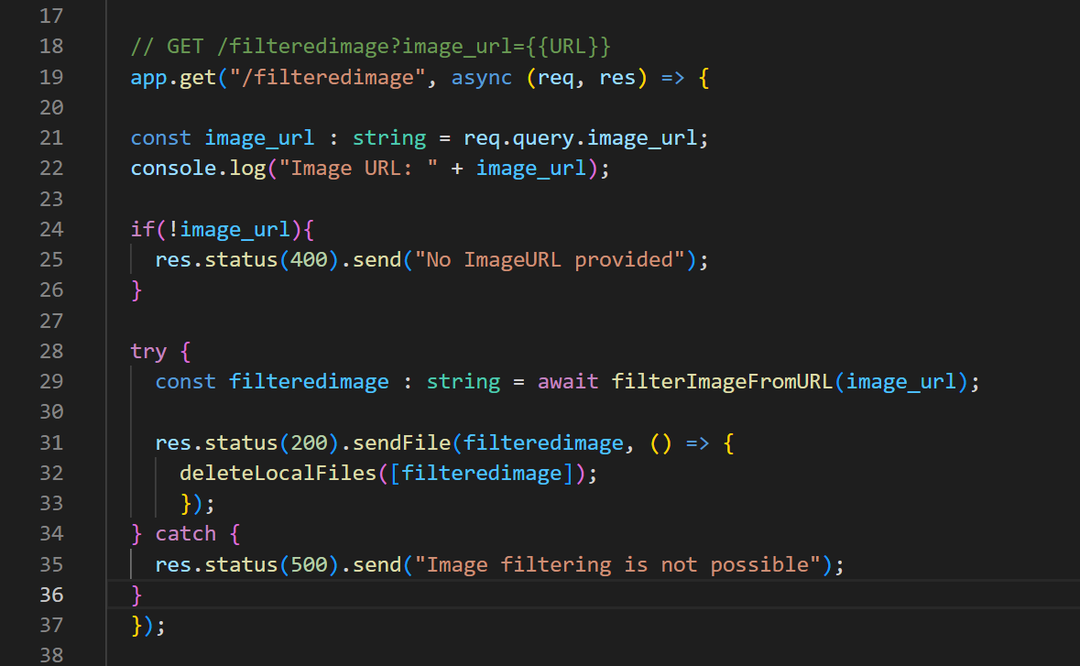

1. **The project demonstrates the ability to develop using the Nodejs framework**

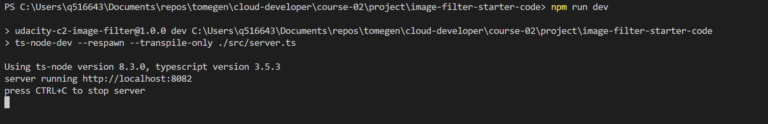

1. **The project demonstrates an understanding of RESTFUL design:**

The image filtering of this example is not possible. I can`t even reach this page with my browser…

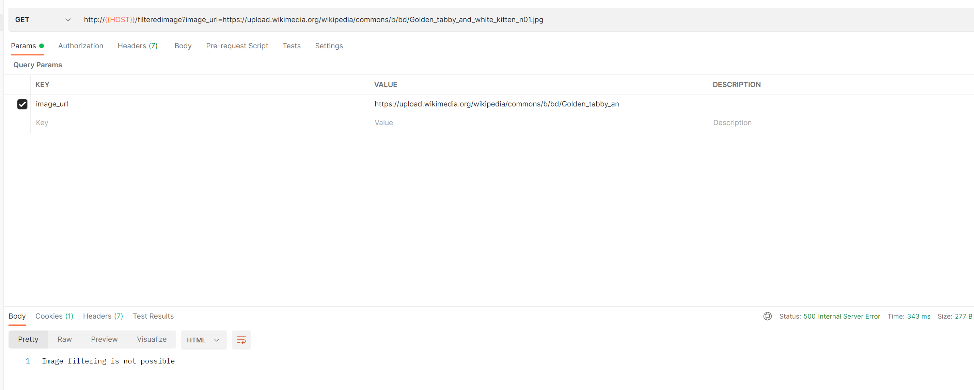

Another valid example is possible:

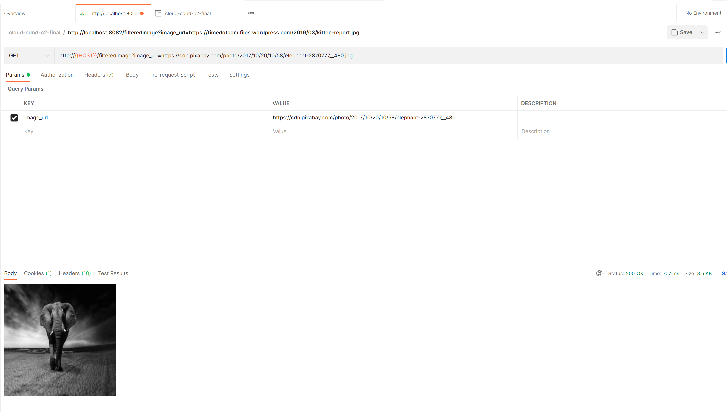

1. **The project demonstrates an understanding of HTTP status codes**

Above you can see a valid request from an elephant 😊

Here is one error that I catch in case no image_url is present:

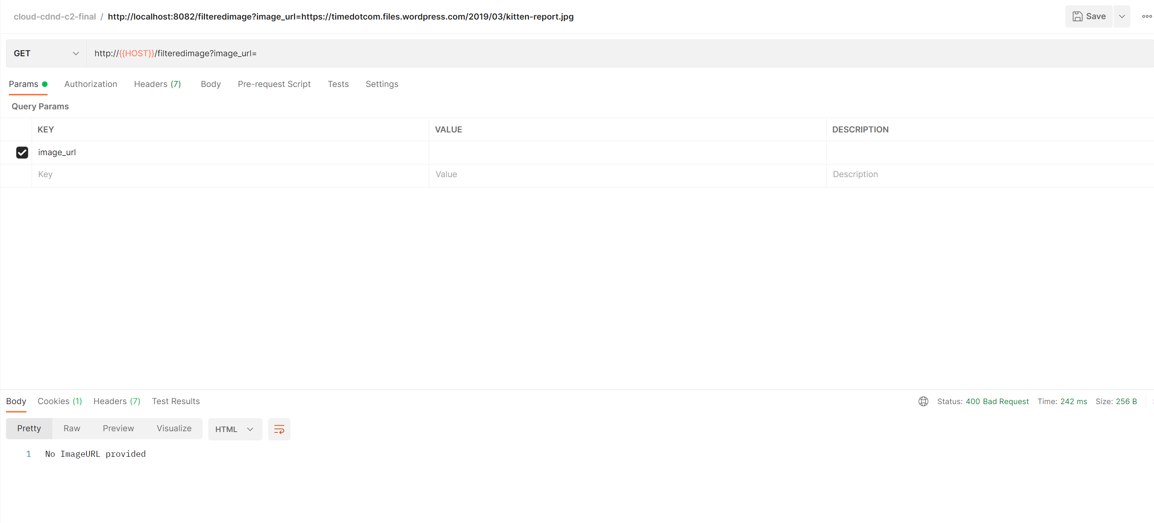

1. **The project demonstrates the ability to create functional cloud deployments**

Here you can find the ElasticBeanstalk URL: <http://image-filter-starter-code-dev2222222222222.us-east-1.elasticbeanstalk.com/>

All examples above are executed with the elastic beanstalk URL:

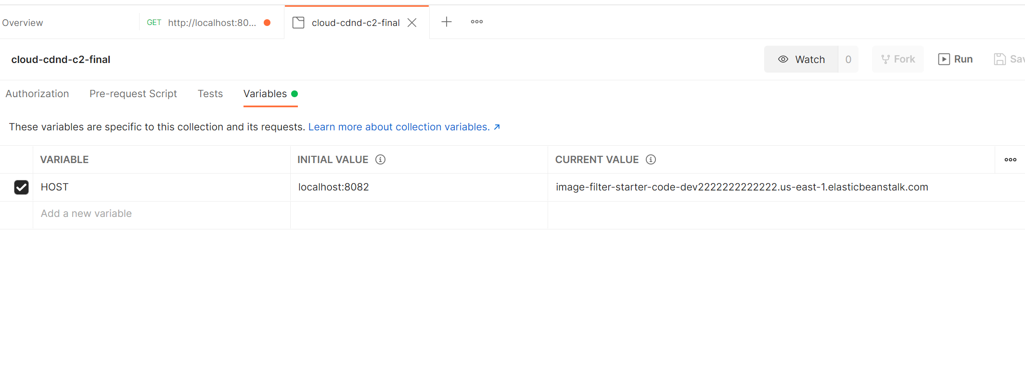

1. **The project demonstrates an understanding of AWS Elastic Beanstalk`s CLI and Console Dashboard**

Eb init: 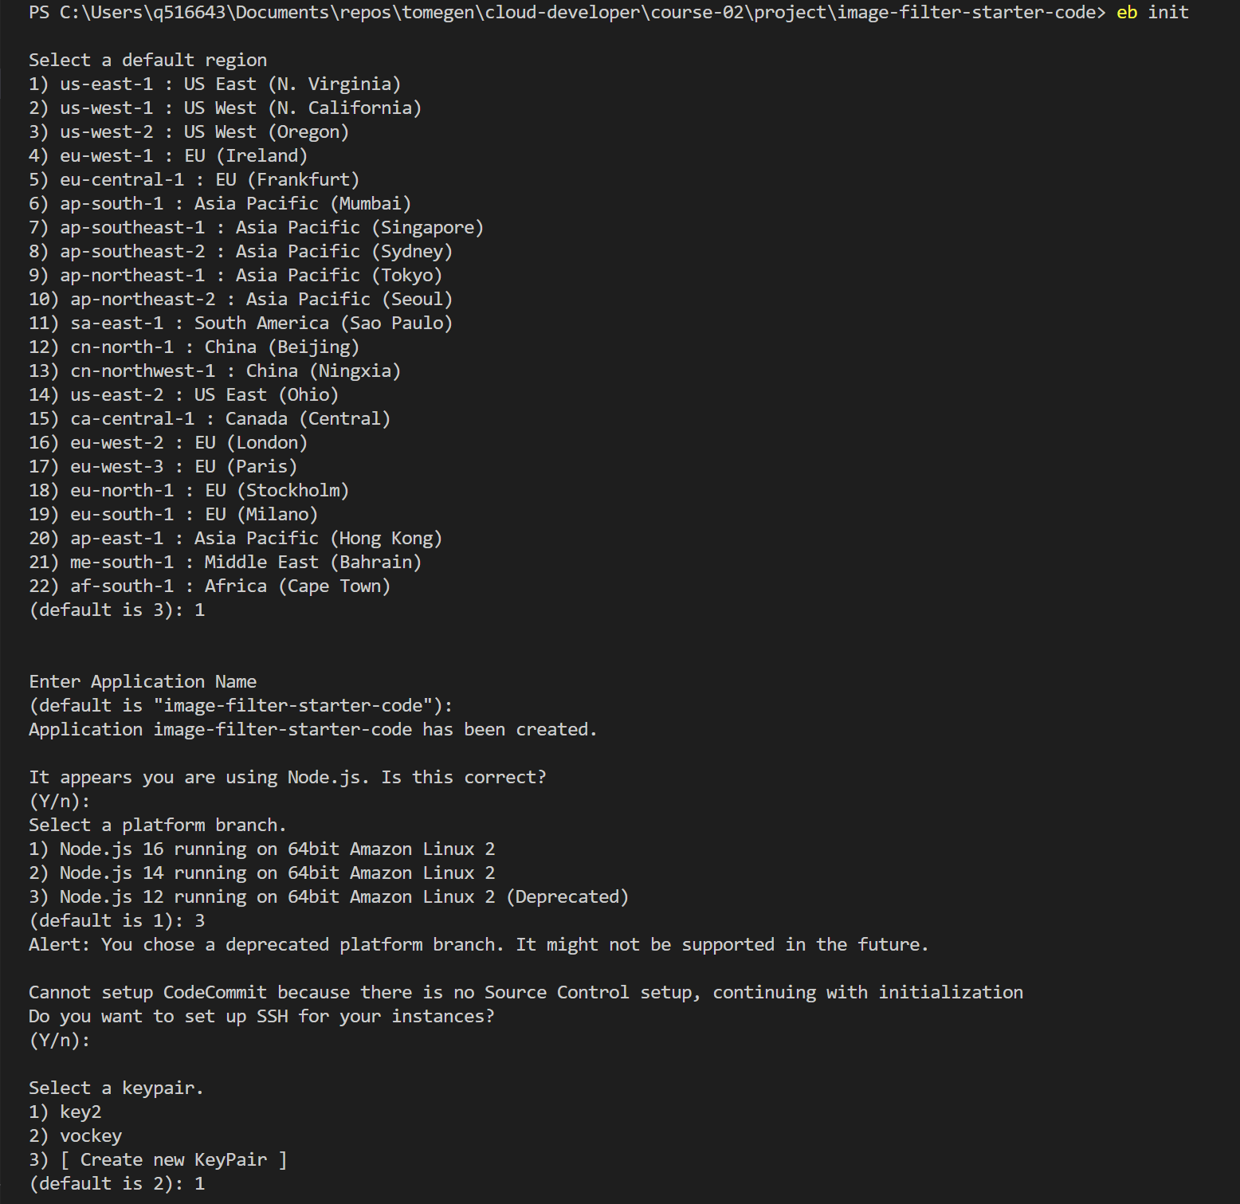

Eb create:

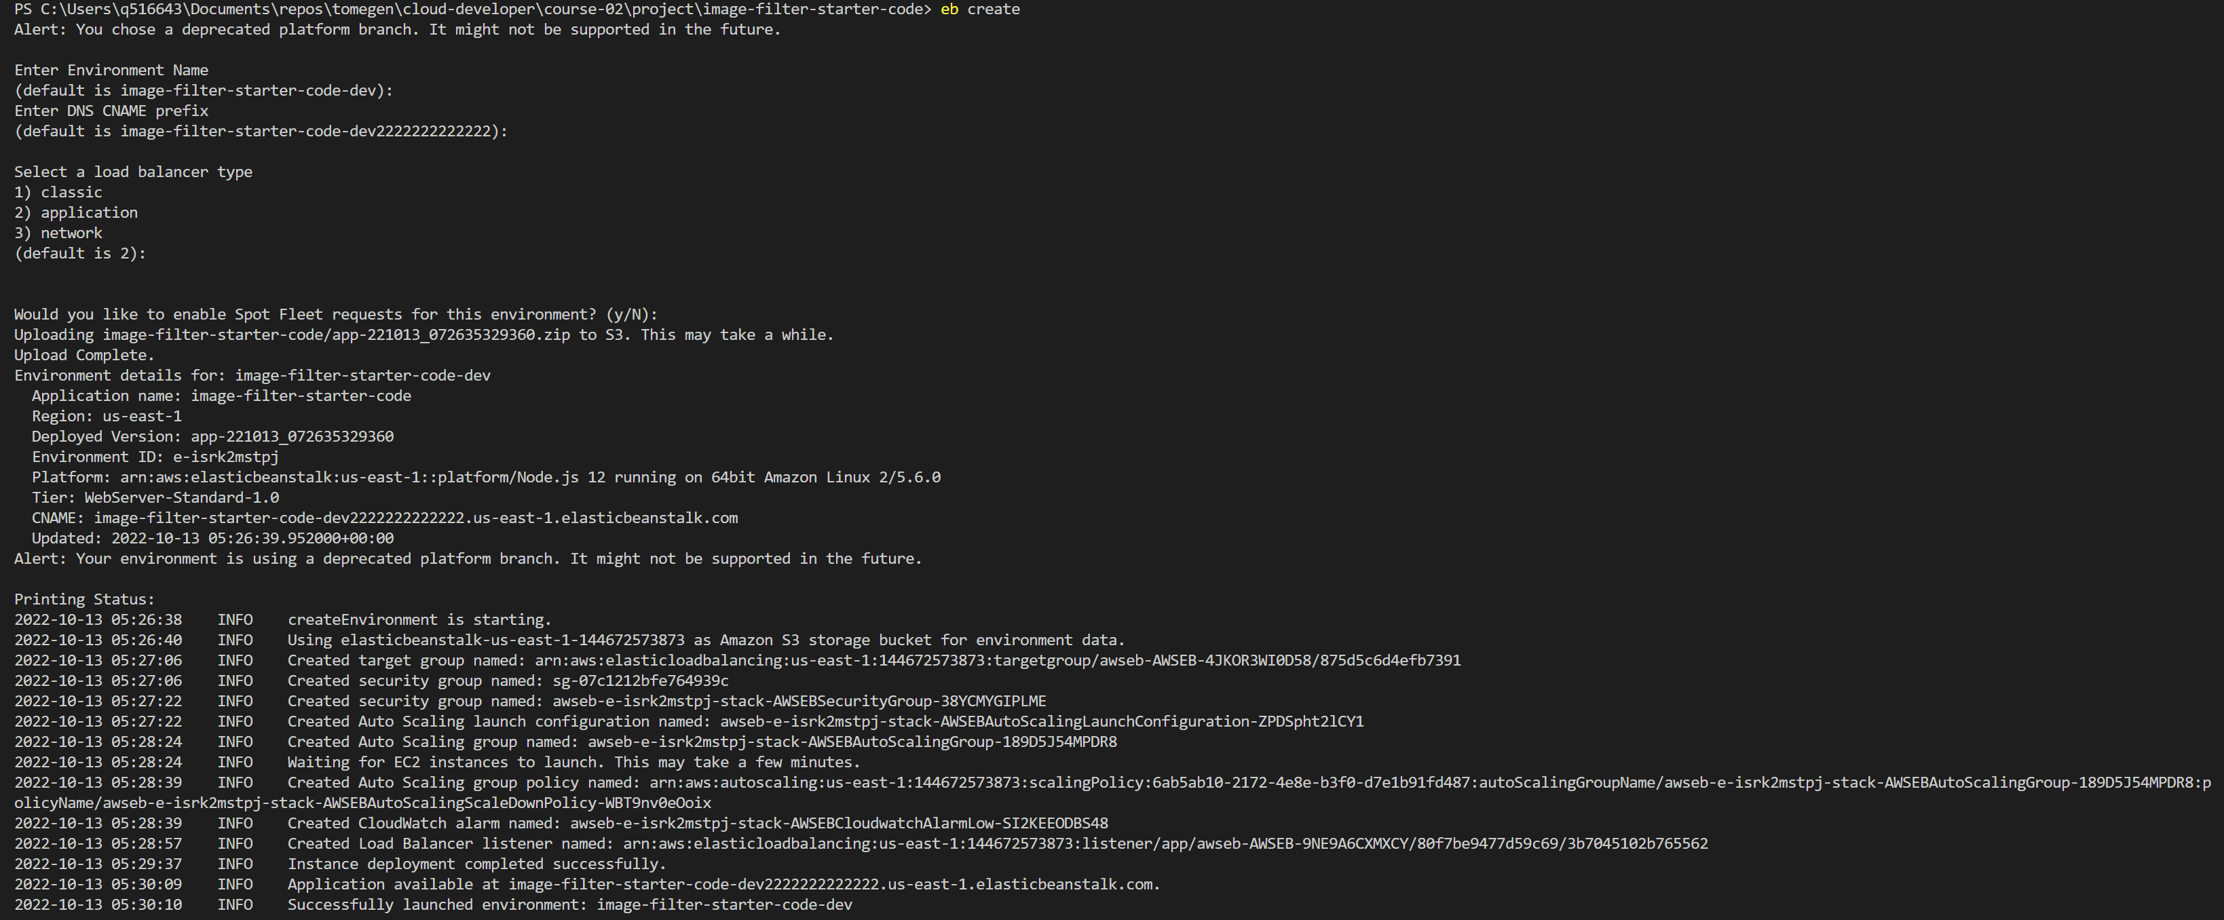

Eb deploy was not needed, because it worked for the first time and no new deployment was necessary.

Screenshot of the elastic Beanstalk Application dashboard is included in the deployment_screenshot directory.

**Repository**: <https://github.com/tomegen/cloud-developer>